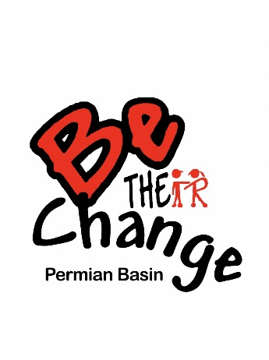
Registration Form
8:00am…Registration
9:00am…Shoot Begins
11:00am…Lunch/Prizes
*Lunch Provided

Title Event Sponsor
CLAY SHOOT ‘23
April 28th, 2023
Jake’s Clays
For Questions Contact:
Regina Lynn
Phone: 432-266-0792
Email: rrodriguez@brhas.com

13301 FM 1379 Midland, Tx 79706
- ONLINE PAYMENT OPTION FOR SPONSORSHP LEVELS:
https://www.bethechangepermianbasin.org/events
- SUBMIT THIS COMPLETED FORM TO: P.O. BOX 52643, Midland, Texas 79710 OR email
hmcbride@btcpb.org
(*Please make checks payable to Permian Basin Be The Change
Contact Information:
Team Captain: |  | Company:
Email: |  | Phone Number:
Choose one of the following:
1. Sponsor
please check desired sponsorship level
 | SPONSORSHIP INFORMATION
☐ | Platinum  $5,000 | - Golf Cart Sponsor (Only 2 Available)  - 4 Complimentary Golf Carts (If needed)  - 2 Teams (8 FREE Shooters)  - On-Course Station  - Sponsor Banner  - Path Sponsor | Please let us know if you need the complimentary golf carts.  ☐ Yes ☐ No
☐ | Gold  $3,000 | - 4 Complimentary Golf Carts (If needed)  - 2 Teams (8 FREE Shooters)  - On-Course Station  - Sponsor Banner  - Path Sponsor | Please let us know if you need the complimentary golf carts.  ☐ Yes ☐ No
☐ | Silver  $1,500 | - 1 Team (4 FREE Shooters)  - Sponsor banner  - Path Sponsor
☐ | Bronze  $500 | - Path Sponsor

Item | Rate | # | Price
1 x 4 Man Team | @ $700.00
1 Shooter | @ $175.00
1 x 2 Man Cart | @ $85.00
Subtotal
2. Participant

